***Os Assignment no 1***

***20K-0368 Hammad Shakeel***

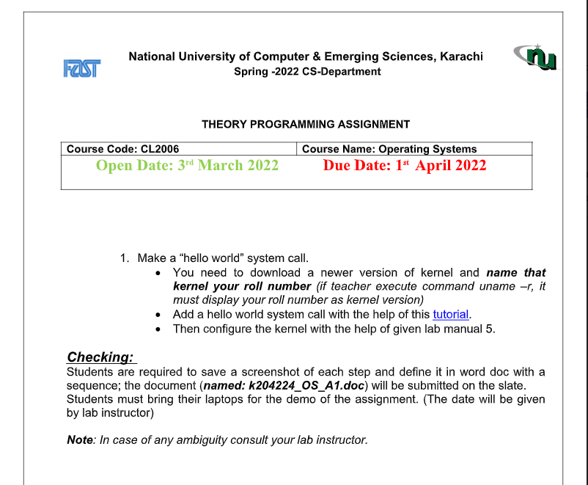

Below is the complete process with description for the tasks given above.

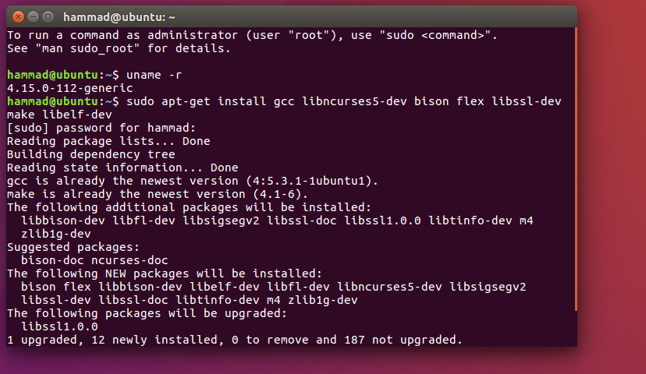

This is the initial name of our system and our task is to change it with our IDs.

And our second task is to print hello World through System calls.

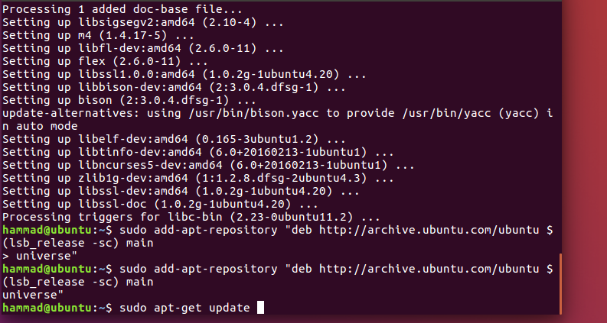

First we get some update in our system.

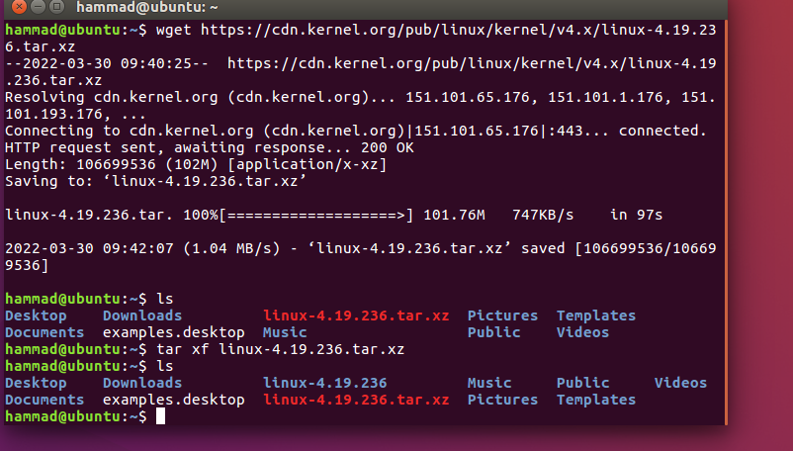

After the update download the new kernel in the system.

After downloading install this file in your system by using the command given above i.e. tar xf <filename>

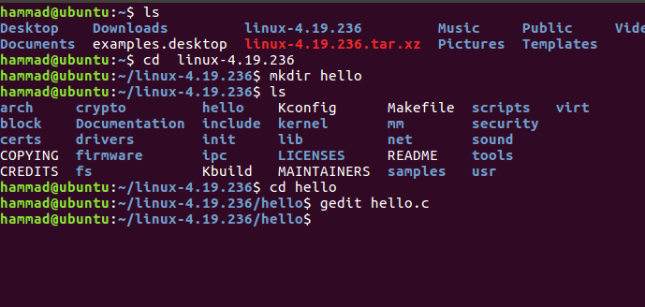

After the installing a directory will be created with the name of the kernel installed. In this directory create a sub-directory name hello and in the hello directory create a .c file and write the below code in it.

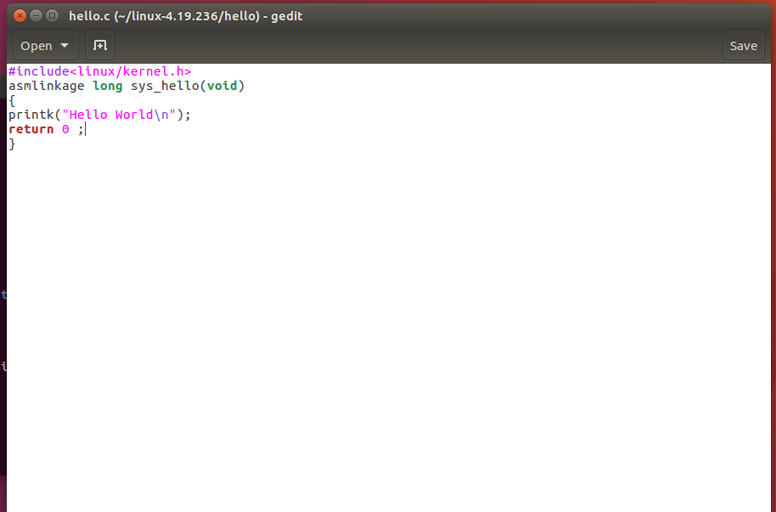

Save the file then exit.

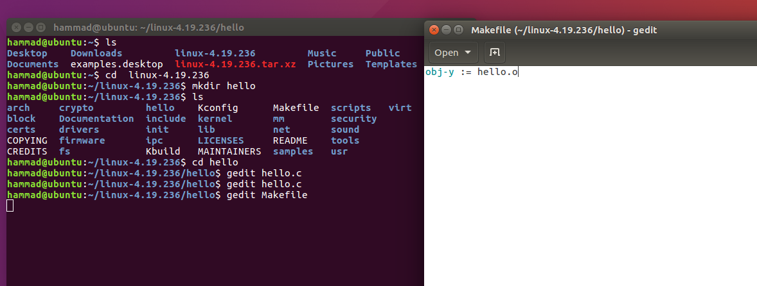

Create another file in the same directory and name this file as Makefile then write the same line given in picture. Then save the file and exit.

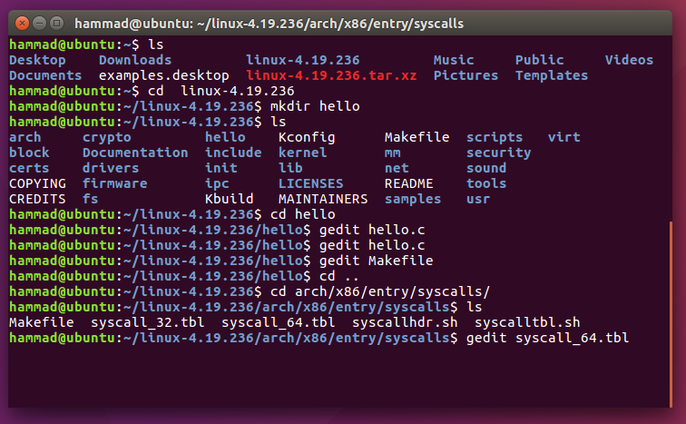

Now open the system file, with the path given above, to make some changes in it.

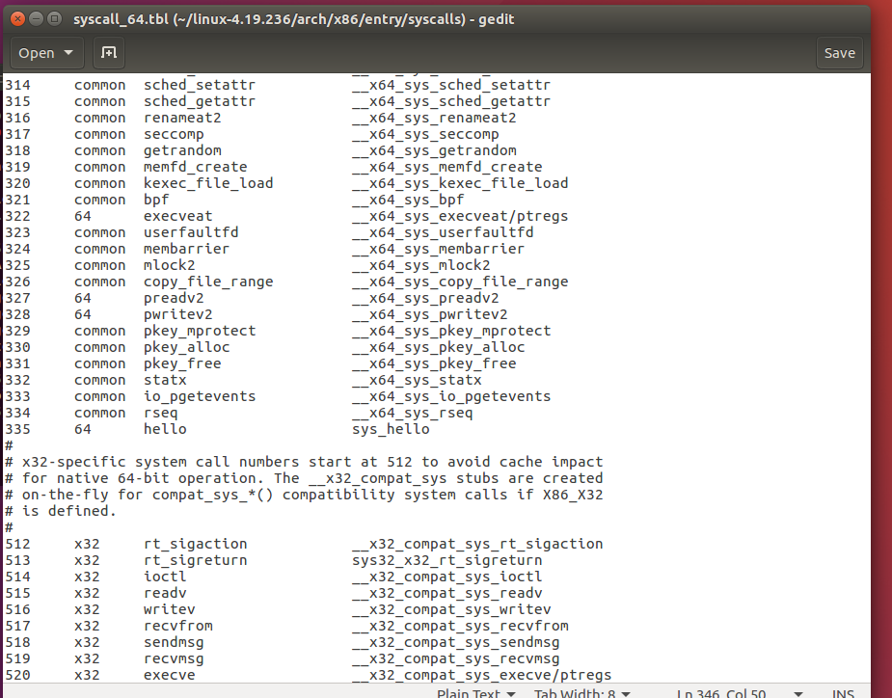

In this file add an extra line (335 in our case) and note the line number for later use. Now save the file and exit.

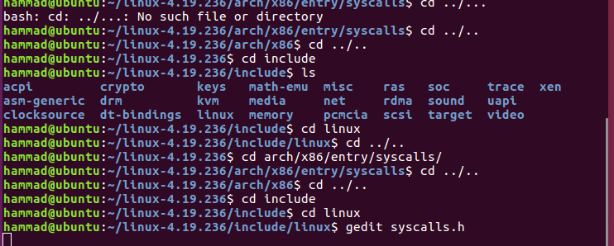

Now we have to change another system file present in the above directory.

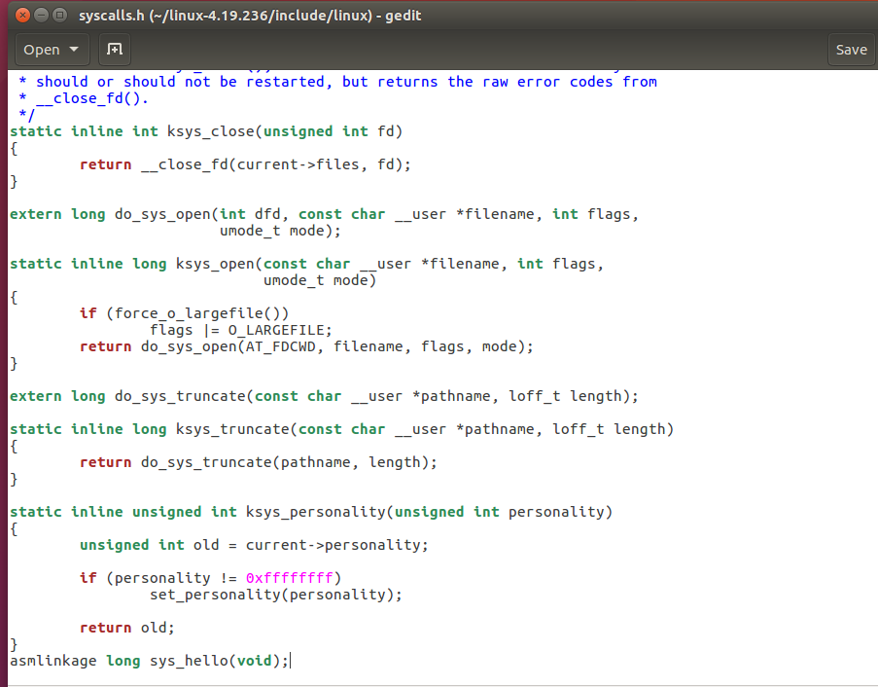

In this file add a line of code (asmlinkage long sys_hello(void)) in very end of the file. Save the file and the exit.

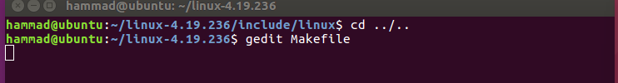

Open another file named Makefile.

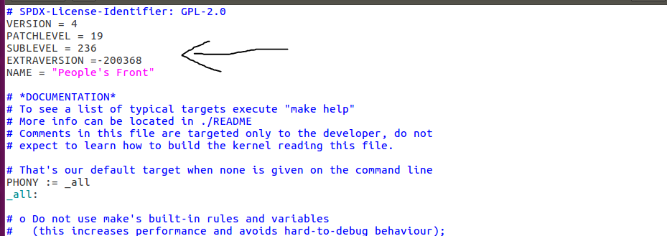

In this file we have to do two things:

1. Updating the name of the system with our IDs (as changed in the above picture).
2. And then search for the core-y in the file by pressing ctrl+f and then write ‘ hello/’ in the end.

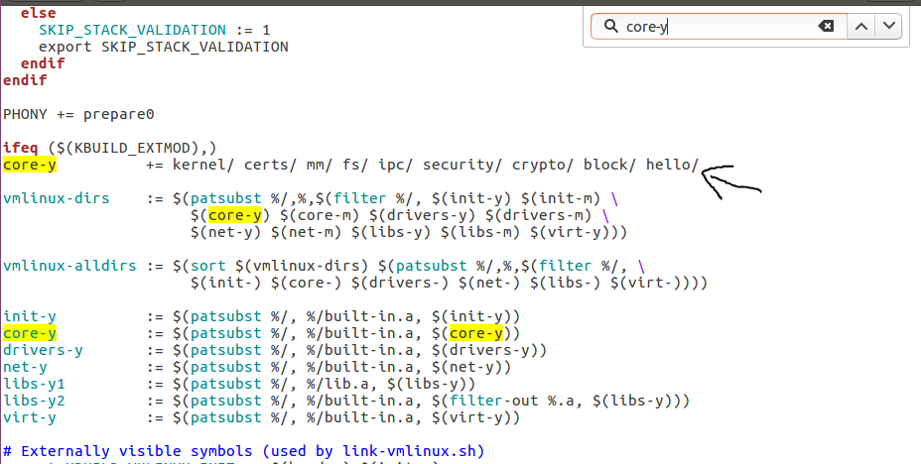

Save and exit the file.

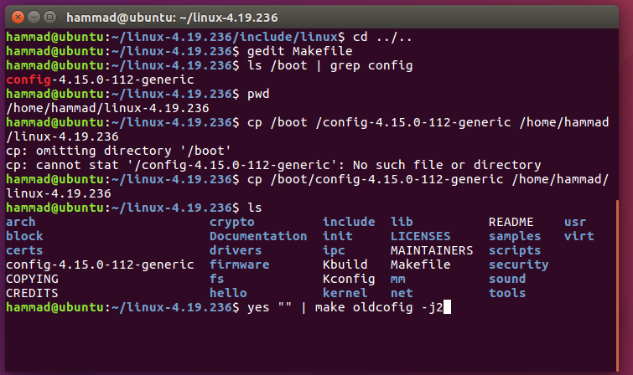

Now copy the configuration file. And the make the oldconfig using the command “yes “” | make oldconfig –j2”.

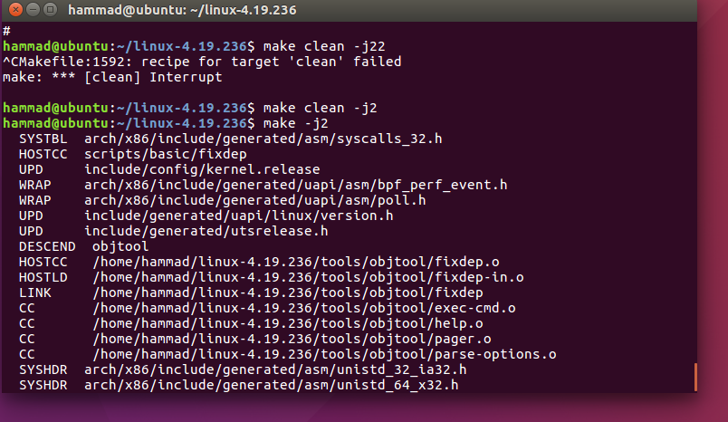

Then write the “make clean –j2” command. After this we have to compile the files by using “make –j2” or “make -j4” command.

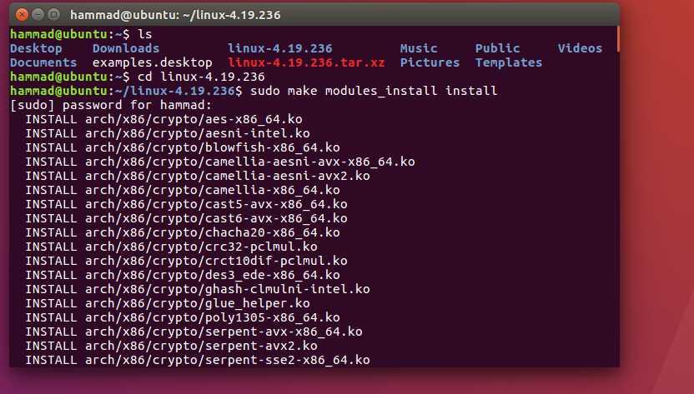

The compiler may take longer but after that we have to install the necessary modules through “make modules_install install” command.

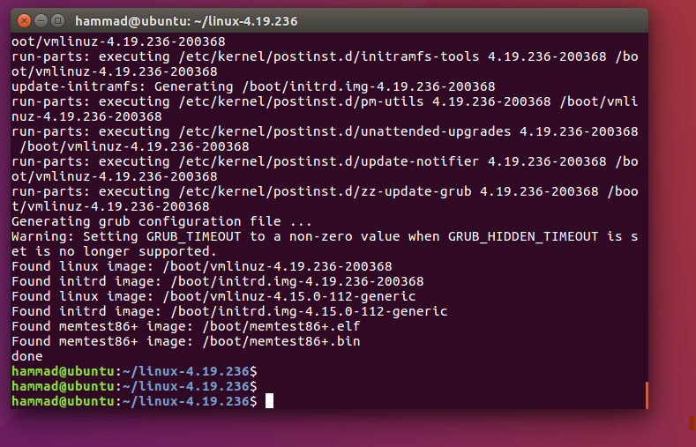

Now the modules have been installed successfully.

Now shutdown the system or reboot.

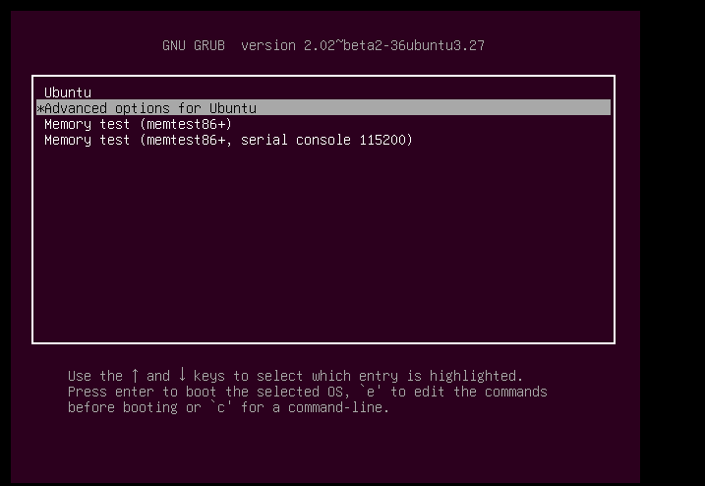

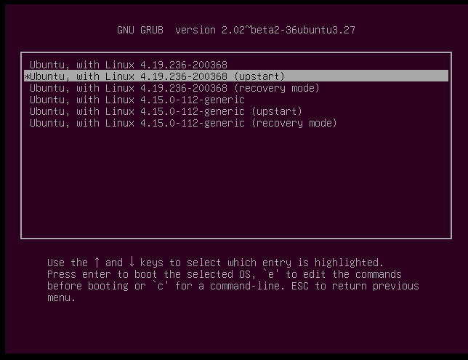

Follow the above process.

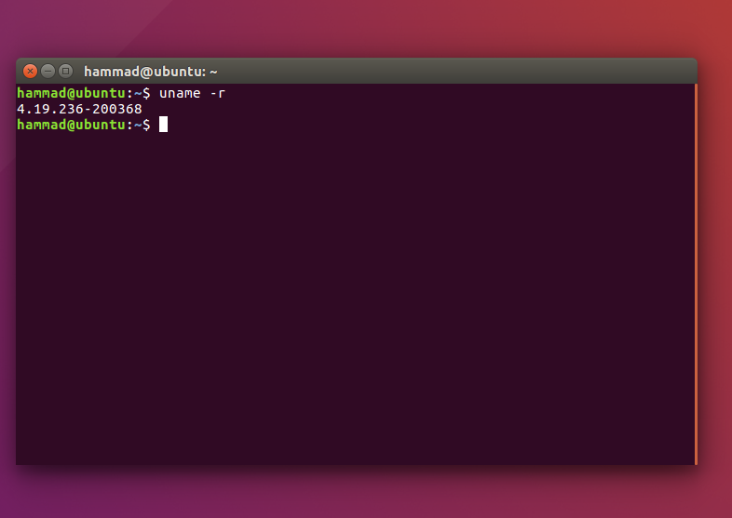

Once you have done with all the system changes type the “uname –r” command.

And voila you have successfully changed the system name.

Done with the task 1.

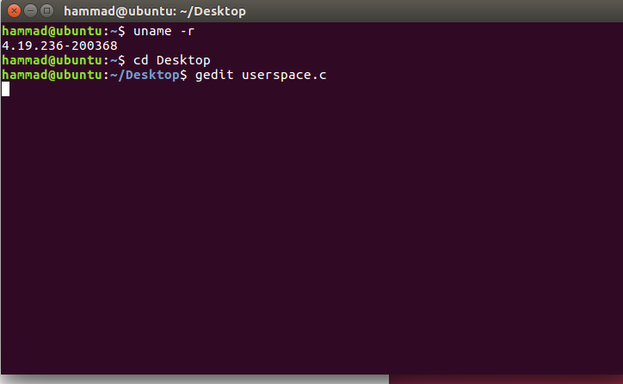

Now to complete the task 2 create a .c file and write the below code in it.

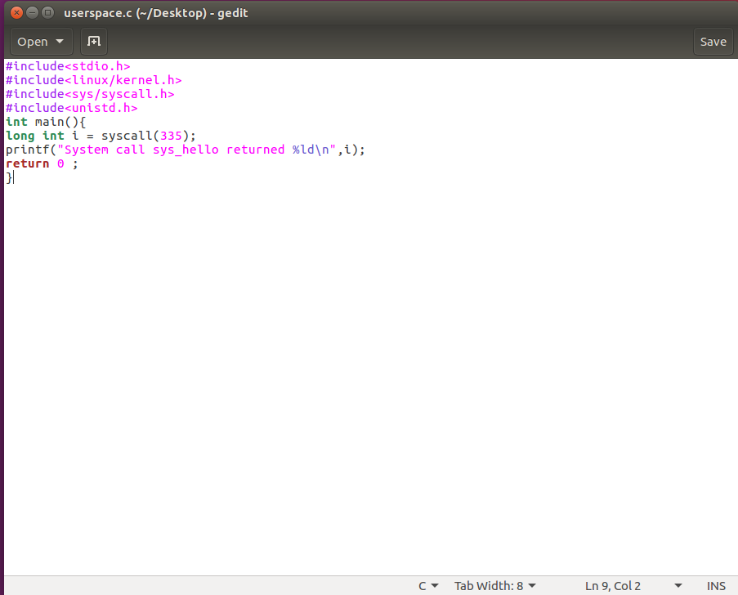

Save and the exit.

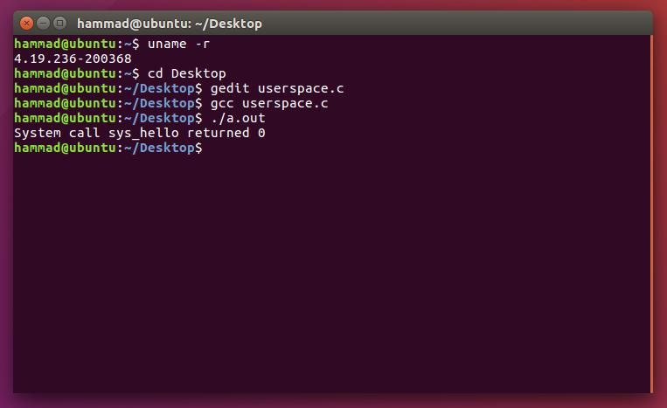

Compile the above code and the run.

If the return value i.e. the output, is 0 it means you have successfully done you’re your task and id the output is -1 then it means you are missing something while changing the system file or compiling.

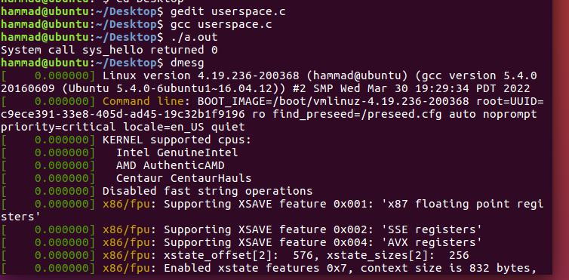

Write “dmesg” to check the output at the kernel level.

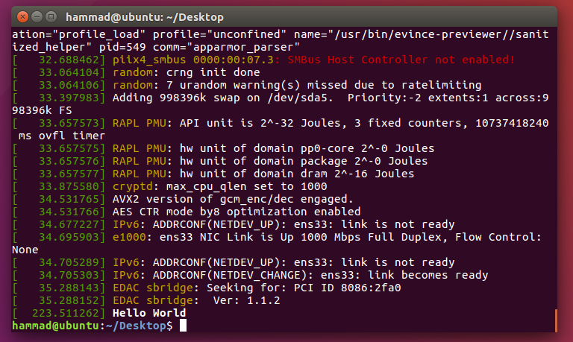

Since the return value was 0 that’s why we get hello World print at the kernel level.

And this was the second task.